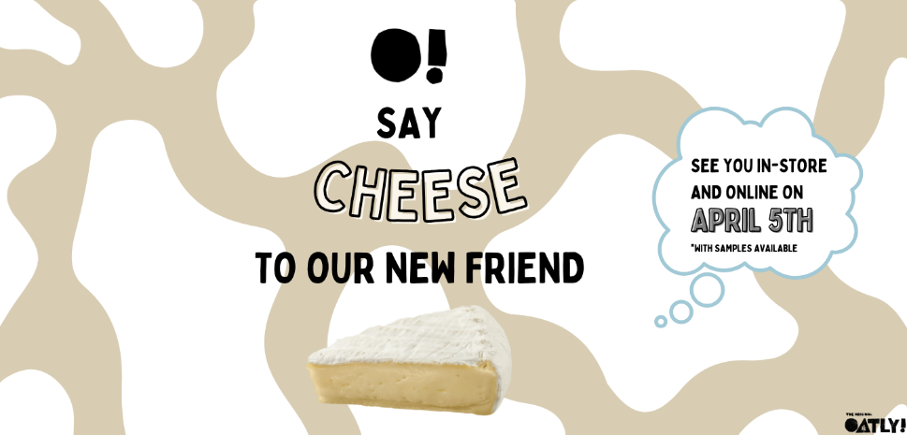
OOH Tagline for Oatly New Cheese:
Main Tagline: O! Say Cheese to Our New Friends!
More information on the billboard: See you in-store and online on April 5th. *With Sample Available
Creative Brief: Our primary audience encompasses loyal Oatly oat milk customers, individuals who adhere to gluten-free and dairy-free dietary preferences with a higher-level disposable income. Given Oatly's premium pricing relative to other plant-based cheese brands, our new cheese product will also be positioned at a higher price point, appealing to a demographic willing to invest in quality.
This advertising campaign will be executed through OOH placements strategically located near supermarkets that carry Oatly products and in densely populated CBDs. These locations are chosen to maximize visibility among potential customers, particularly those headed to supermarkets, thereby raising awareness of Oatly's latest offering and increasing sales. The inclusion of sample availability in supermarkets within the OOH messaging is intended to entice trial among our target audiences.
By situating OOH advertisements in CBD areas, we aim to enhance Oatly's brand recognition beyond its established oat milk product line, thereby reinforcing its identity as a comprehensive provider of oat-based foods. This approach not only familiarizes a broader audience with Oatly's diverse offerings, including milk, yogurt, ice cream, and cream cheese but also facilitates a shift in perception of Oatly from merely an "oat milk" brand to a broader "oat-based food" company.
This strategic advertising initiative supports Oatly's mission to expand the oat-based food category and encourages a wider adoption of such products. By introducing and promoting the new dairy-free cheese, we align with Oatly's objective of "driving category growth" and fostering a more inclusive approach to plant-based eating, thereby appealing to a diverse and environmentally conscious consumer base (Crawford, 2024).
References
Crawford, E. (2024, January 11). Can oatly reinvigorate slowing oatmilk category sales with launch unsweetened, clean-label options?. foodnavigator. https://www.foodnavigator-usa.com/Article/2024/01/11/can-oatly-reinvigorate-slowing-oatmilk-category-sales-with-launch-unsweetened-clean-label-options#

