Oatly Infographic: 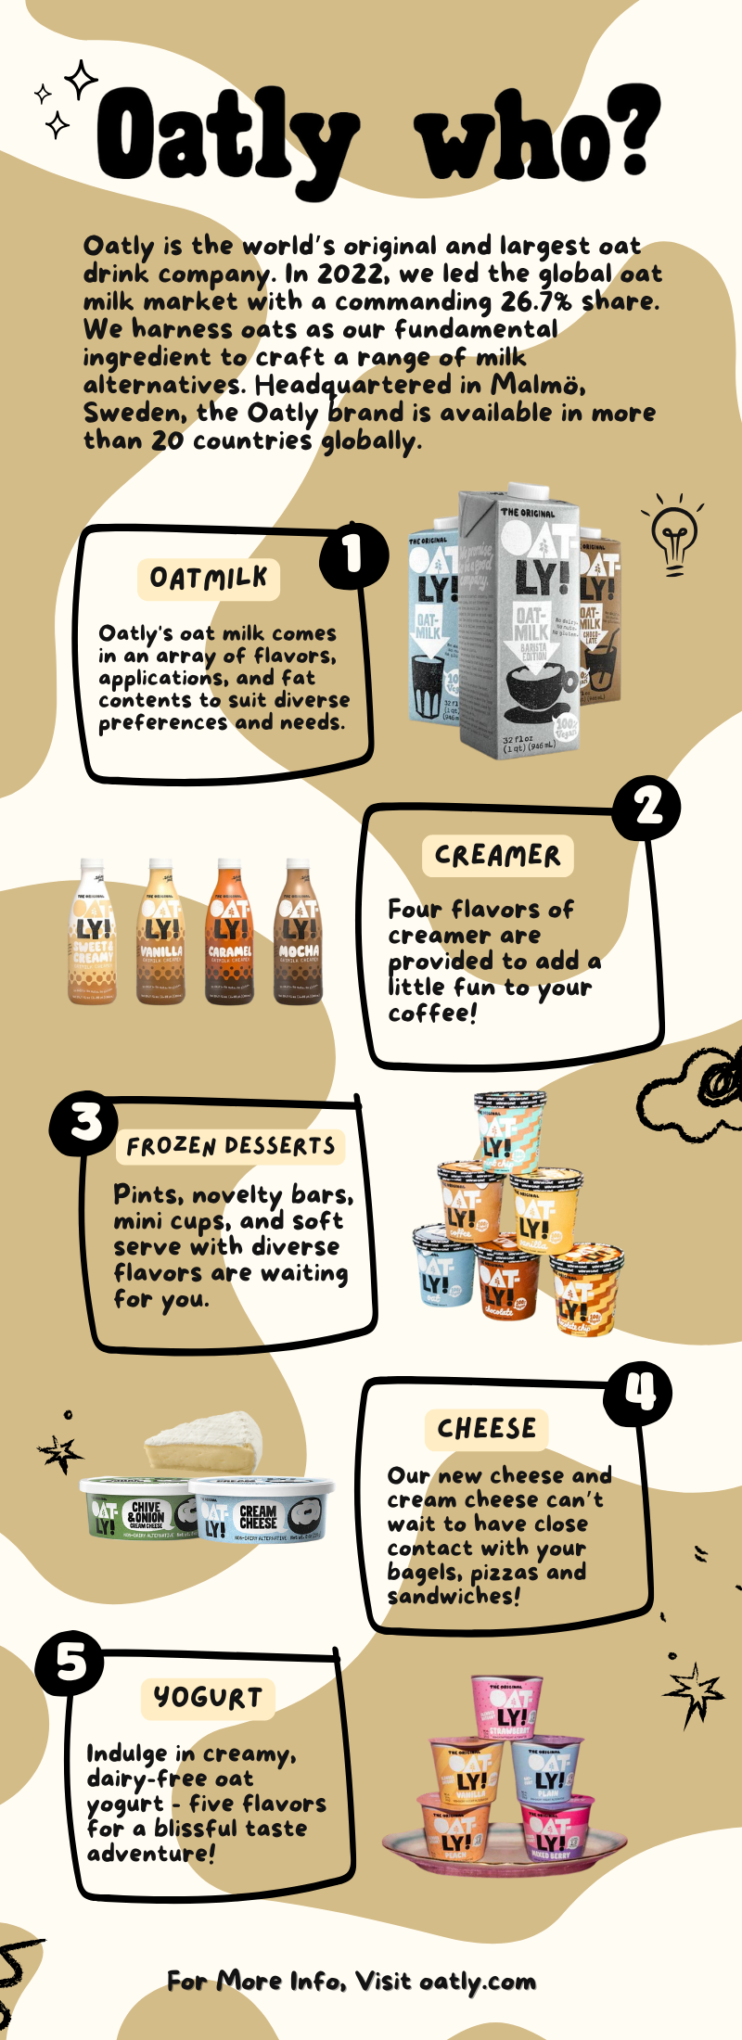
Information in the infographic:

Oatly Who?
Oatly is the world's original and largest oat drink company. In 2022, we led the global oat milk market with a commanding 26.7% share (Mordor Intelligence, 2023). We harness oats as our fundamental ingredient to craft a range of milk alternatives. Headquartered in Malmö, Sweden, the Oatly brand is available in more than 20 countries globally (Oatly, 2024).

Oatmilk
Oatly's oat milk comes in an array of flavors, applications, and fat contents to suit diverse preferences and needs.

Creamer
Four flavors of creamer are provided to add a little fun to your coffee!

Frozen desserts
Pints, novelty bars, mini cups, and soft serve with diverse flavors are waiting for you.

Cheese
Our new cheese and cream cheese can’t wait to have close contact with your bagels, pizzas and sandwiches!

Yogurt
Indulge in creamy, dairy-free oat yogurt—five flavors for a blissful taste adventure!

For More Info, Visit oatly.com

References
Mordor Intelligence, M. (2023). Oat Milk Market Size & share analysis - industry research report - growth trends. Oat Milk Market Size & Share Analysis - Industry Research Report - Growth Trends. https://www.mordorintelligence.com/industry-reports/global-oat-milk-market
Oatly sets sail with Virgin Voyages, marking its first cruise line distribution deal. Oatly Group AB. (2024, March 25). https://investors.oatly.com/news-releases/news-release-details/oatly-sets-sail-virgin-voyages-marking-its-first-cruise-line

